**Kong: Requirement Specification**

### Bader Albader

|  |  |  |  |
| --- | --- | --- | --- |
| **Date** | **Revision** | **Revision By** | **Changes Made** |
| 06/11/18 | 1.0 | Bader Albader | Document created |
| 06/18/18 | 2.0 | Bader Albader | Wrote down requirements discussed in meeting into this document |
| 06/19/18 | 2.1 | Jacob Tran | Added chart and section 4, Project Management. |
| 06/19/18 | 2.2 | Tyler Valentine | Added section 5, Scrum Notes. |
|  |  |  |  |
|  |  |  |  |

## **Table of Contents**

### **1. Introduction**

1.1 Purpose

1.2 Scope

1.3 Overview (high level view of key points in this spec)

**2. Overall Description**

2.1 Product Perspective

2.2 Product Functions

2.3 User Characteristics

**3. User Stories**

3.1 User Story 1

3.2 User Story 2

3.3 User Story 3

**4. Project Management**

4.1 Schedule

**5. Scrum Notes**

5.1 Scrum Specifics

5.2 Bader Albader

5.3 Charles Mezhir

5.4 Jacob Tran

5.5 Tyler Valentine

5.6 Garrett Senor

**1. Introduction**

1.1 Purpose

We are trying to produce a product to monitor and communicate useful data within a greenhouse environment in order better maintain ideal growing conditions. The product will use a webpage to display real-time and historical data in order to facilitate a healthy growing environment and better manage resources. The program will utilize hardware to monitor current conditions within the greenhouse which the user can view from the webpage. Additionally, historic data will be stored in a database so that trends within the growing environment can be analyzed. The hardware will communicate with the database through Wifi or bluetooth connectivity.

1.2 Scope

KONG-GROW will be the premiere temperature and humidity monitoring software accessible to amateur and professional growers. Its web-based design will provide an affordable and user friendly approach to maintaining and optimizing greenhouse environments as well as maximizing profits through efficient resource management.

**2. Overall Description**

2.1 Product perspective

**System Interfaces**:

|  |  |  |  |
| --- | --- | --- | --- |
| System Requirement | Input | Software Transformation | Output |
| Hardware  connectivity to  wifi | Microcontroller. | C, Python | Wifi connectivity. |
| Data  transmitted to  database. | Sensor data | SQL, NodeJS | Data stored in database. |
| Data displayed  on front end  website. | Database information | HTML, CSS | Data shown in frontend. |

**User interfaces** :

|  |  |  |  |
| --- | --- | --- | --- |
| Interface | Display Layout | Description | Constraints |
| Front end | Website | Will contain a  login system and  data from  temperature and  humidity sensor. | Locations to test project. |
| Backend + Middle Layer | SQL, NodeJS | Will store data  information of  login information  and temperature +  humidity  information. | Size of  database and  speed to data  acquisition. |
| Hardware | No display | Will track and  manage data and  send the data over  wifi to the  database. | Testing and  accuracy of  data  acquisition. |

2.2 Product functions

|  |  |
| --- | --- |
| Priority Level | Function |
| **HIGH** | Hardware connectivity to wifi. |
|  | Hardware data acquisition. |
|  | Database. |
| **MEDIUM** | Front end website functionalities. |
| **LOW** | Website looking pretty. |

**3. User Stories**

3.1 User Story 1

Farmer wants to monitor the temperature of his greenhouse in real time to

minimize losses due to under-managed temperatures

Ranking among stories: 1 (for first round) changed to 2 after debate

3.2 User Story 2:

Systems admin who wants a way to encrypt a password database

Ranking among stories: 2 (for first round) changed to 1 after debate

* Reached a consensus after it was pointed out that public algorithms

can be used.

3.3 User Story 3:

Computer science professor who wants a way to check to see if students

are submitting plagiarized code.

Ranking among stories: 3

**4. Project Management**

4.1 Schedule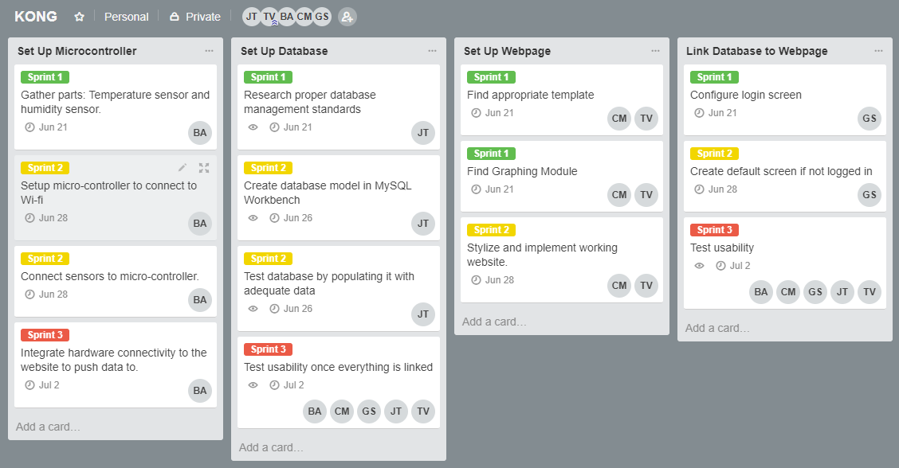

**5. Scrum Notes**

5.1 Scrum Specifics

Tyler Valentine took the role of scrum leader and Garrett Senor was unfortunately unable to attend due to unanticipated travel delays.

5.2 Bader Albader

Bader has been working on determining what specific sensors would be needed for the hardware aspect of the project. He has compiled a list and will be working on acquiring the necessary equipment and beginning implementation leading up to our next meeting. Additionally, he has been building and updating the templates needed for the group to properly record and document this project and worked on our milestone 2 submission.

5.3 Charles Mezhir

Charles has been researching templates for the website as well as determining what plugins we will need in order to display real time and historic data on the front-end in graphical form. By our next meeting he will have determined our website format and any additional software we will be using to move forward.

5.4 Jacob Tran

Jacob has been researching database standards and protocols to determine the most efficient way to implement our database for the project. He also organized the Trello page, assigning tasks to relevant parties, worked on aspects of our milestone 2 submission, and spend time making sure that all members of the group are familiar with how github and Trello function so we can communicate as effectively as possible. Currently he is working on finalizing our database management standards.

5.5 Tyler Valentine

Tyler has been expanding his working knowledge of html so he will be able to assist Charles with the front end development. He also set up the Trello page and worked with Jacob to make sure everyone was assigned to the proper tasks and that the formatting was as clear as possible. Finally, he met with the professor to ensure that our milestone 1 submission met all requirements and contributed to the milestone 2 submission. Currently he is assigned to double-checking our milestone 2 submission and finalizing website templates and plugins with Charles.

5.5 Garrett Senor

Garrett was, unfortunately, unable to attend the scrum, however, he has been working on connecting the front end with our database using java script. Tyler and Jacob met with him in/after class today to fill him in on all developments and he will continue to work on the middle layer leading up to our next official meeting.